Using Routine Leaching Fraction Testing to Guide Irrigation in Container Nurseries

*DRAFT March 2, 2021 Jeff Million*

**Goal** Apply amounts of irrigation water that maintain optimal plant growth but with minimal container drainage (leachate). If successful, water is conserved, pumping costs are minimized, and, due to reduced leaching, agrichemical effectiveness is increased.

**Why is irrigation management difficult in container nurseries?** Two major factors are container substrate volume and variability in plant production conditions.

1. Containers have a limited volume of substrate for holding water, providing little buffer between under- and over-watering. It also means that frequent (typically daily or multiple times per day) irrigation is required. Frequent irrigation intensifies the need to apply precise amounts of water. The capacity of a substrate to retain irrigation water is generally very high if an efficient irrigation schedule is maintained but a substrate’s capacity to retain water can be reduced if the substrate dries out either rapidly from missed irrigation, or slowly over time due to under-watering and/or lack of rain.

2. Variability in production conditions can not be avoided but minimizing variability (increasing uniformity) will determine in large part how successful a precision irrigation management system will be. Three general sources of variability affecting irrigation are the irrigation system, plant production conditions, and the weather. While weather can not be modified, its effect on irrigation is obvious and needs to be considered objectively.

a) Irrigation system variability. For precise irrigation, the system needs to apply water uniformly within a given irrigated area (zone). Furthermore, uniformity in water delivery needs to be consistent from one day to another. Uniformity can be easily evaluated (<https://edis.ifas.ufl.edu/ep458>) but difficult to correct if the system was not originally designed to be uniform. In general, if uniformity is low (DU <80%), changes to the infrastructure are indicated. Minor adjustments can sometimes help. For example, with sprinkler-irrigation, low output areas may need higher flow rate nozzles.

b) Plant production conditions variability. The more uniform plant conditions are within a given irrigated zone, the better opportunity there is for precision irrigation. Ideally, all plants within an irrigated zone were planted in the same substrate, in the same container, with the same sized transplant, and at the same time. Furthermore, ideally the plants grew at a similar rate and were pruned to a similar size resulting in plants with equal water needs. As with non-uniform irrigation systems, there is little chance for efficient irrigation when plant conditions are not uniform.

c) Weather variability. Weather affects the rate of evaporative water loss from plants and substrate (evapotranspiration or ET). Furthermore, rain can reduce or eliminate the need to irrigate. Because weather changes from day to day and from season to season, accounting for weather will provide the best opportunity to apply water efficiently.

While variability in plant production is unavoidable, insight into this variability allows the irrigation manager to best determine how to account for the variability when deciding on a plan of action. More on this after discussing a routine leaching fraction test.

**Routine leaching fraction testing** The leaching fraction is a measure of the amount of leachate that results during irrigation. Specifically, the leaching fraction is the amount of leachate divided by the amount of irrigation water applied to the container (LF=leachate/irrigation; <https://edis.ifas.ufl.edu/ep529>). A LF test is based on a 24-hour period if more than one application cycle per day is scheduled. Based on routine LF testing, irrigation can be adjusted to target a low LF. Research has shown that a target LF of 10-15% is attainable for sprinkler irrigation while a higher target LF (20-25%) may be needed to sustain optimal production of micro-irrigated plants in larger containers.

Adjustments to irrigation following a LF test can be made according to:

New run time = Run time x (100% - LFtest%) ÷ (100% - LFtarget%)

For example, if run time = 40 min, LFtest = 30%, and LF target =15%, then

New run time = 40 x (100-30) ÷ (100-15) = 40 x 70 ÷ 85 = 33 min

**Some tips for routine leaching fraction testing:**

1. Strive for testing an irrigation zone once every two weeks. More frequent testing is suggested during phases of rapid plant growth. This is particularly the case as plants transition from winter dormancy to active spring growth when temperatures rise rapidly, and days get longer.

2. During phases of rapid growth such as in the spring, irrigation requirements can rise rapidly. During this period, it is common to get “behind” in irrigation. To avoid getting zero leachate during LF testing, it can help to increase irrigation (e.g., 10-20%) prior to conducting a LF test.

3. Routine LF testing should include multiple test plants that account for variability. Three or four test plants should be enough in most cases. The selected plants should be representative of the highest water needs in the irrigated zone. As far as irrigation system variability, this may mean selecting plants in low output areas. As far as plant production variability, this may mean selecting larger plants or plants on borders with higher ET rates. By selecting LF test plants with higher water needs, there is less chance for under-watering. The trade-off is that other plants in the irrigated zone may be over-watered. Finally, all things being equal, select plants that are easily accessible to make labor more efficient.

4. Routine LF testing should be conducted on normal or high ET days without rain to ensure that adequate water will be applied during other days between LF testing dates. LF tests conducted on days following significant rain may result in higher LF values than if conducted several days later.

**Options for Using routine LF testing to guide irrigation**

1. Manual adjustment New run times based on LF testing are manually implemented. These run times remain unchanged until the next LF test is conducted. If the LF test was conducted on days of normal or high ET, then on days with low ET, this practice will likely result in LF values that are higher than the target LF. A benefit of manual adjustment is that there is little chance for under-watering.

2. Manual adjustment considering weather Some irrigation controllers have an ET adjustment that can be used to adjust irrigation times up or down according to expected weather effects on water demand.

3. Automatic adjustment A more sophisticated irrigation control system can be assembled using a programmable logic controller (PLC), CIRRIG, a container irrigation software program, and a weather station located on-site. LF test data are entered into CIRRIG and the program automatically adjusts irrigation run times daily based on ET weather data including rain. The PLC interfaces with CIRRIG to automatically implement the run times. More details of this system follow.

**Automatic irrigation adjustment with CIRRIG and Routine LF testing**

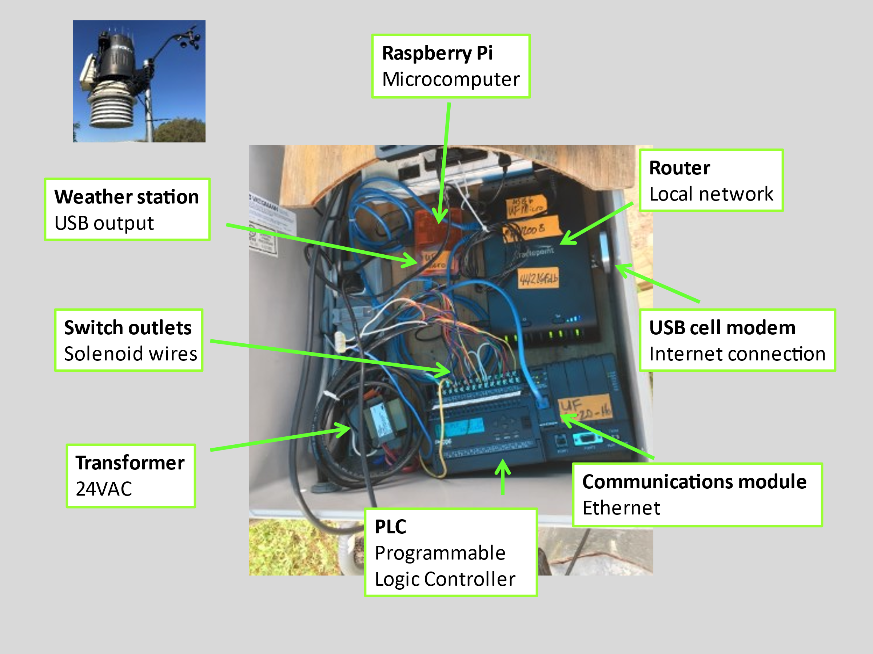

*The core hardware system is comprised of a programmable logic controller (PLC), a microcomputer, a local network with internet connection, a weather station, and a 24VAC transformer. The displayed unit controls 16 solenoid valves.*

Hardware ($5000)

1. Programmable logic controller (D006; automationdirect.com) with a communications module (H0-ECOM100; automationdirect.com). Digital switchboard that controls 16 irrigation valves (more outlets can be added in blocks of 8). Essentially serves as a replacement for a typical irrigation controller. Must be programmed using proprietary software (DirectSoft; automationdirect).

2. Microcomputer (Raspberry Pi; Adafruit.com) contains programs that control several functions:

a) Manages weather data from a wired weather station (Davis Vantage Pro2 Plus; davisnet.com)

b) Managing and monitoring of the PLC via a GUI (graphical user interface).

c) Acquires irrigation data from CIRRIG or can calculate locally if internet connection is lost.

d) Manages and stores irrigation data for historical record-keeping

3. Router with cellular modem provides a network for interconnectivity between PLC, weather station, and microcomputer. A static IPaddress is needed for the cellular modem service. Multiple PLCs can be connected to one router.

4. 24VAC transformer energizes the solenoid valve circuits.

5. Weather station with solar sensor (Vantage Pro 2 Plus; davisnet.com)

Software

1. WeeWX is an open-source weather software written in Python that interacts with the Davis Vantage Pro2 Plus weather station. Used to control the scheduled uploading of weather data. Also provides real-time monitoring of weather.

2. PLC ladder logic program is needed for the PLC to control outlets. Basically, the program receives and implements timer values for each outlet switch as controlled by GUI monitoring program.

3. The GUI program is the dashboard for controlling and monitoring PLC functions. The GUI is used to assign information for each outlet including CIRRIG zone assignments, irrigation application rates, irrigation time schedule, zone groups, maximum zone groups to run at once, manual timers or manual on/off, max run time limits, etc. Other functions include configuration savings, autologin, and default units (metric or English).

4. CIRRIG is a web-based irrigation scheduling program. The user creates irrigation zones and enters information [zone type (sprinkler vs. micro), irrigation application rate, plant descriptor, outdoor vs. indoor, container size, irrigation uniformity, etc.]. CIRRIG also manages and displays hourly and daily weather data from one or more weather stations. Daily irrigation histories can be viewed for each zone. A separate section is used to input routine LF data including the test date and time, irrigation run time, measured LF, and target LF. CIRRIG calculates an ET factor for the LF test and uses this to adjust subsequent irrigation amounts based upon each day’s weather, including rain. The run times for each irrigation zone are calculated just prior to the irrigation event so that the GUI program that sets timer values on the PLC is getting run times based upon the latest weather information.

**New alternative method of LF testing**

The traditional method of LF testing requires collecting leachate, measuring volume, pouring out liquid and storing collectors until the subsequent test. An alternative method that minimizes labor is the use of small rain gauges (photo). With the rain gauge, leachate is not collected but rather directed into a rain gauge placed underneath the drain hole of a pizza pan. The rain gauge has a dual tipping bucket mechanism that tips when a bucket is full (photo). The number of tips can be recorded with a simple electronic pulse counter (photo), and the total amount of leachate calculated by multiplying the number of tips by the volume of each bucket tip (1.6 mL). Because leachate is not collected, the gauges can be left out in the field.

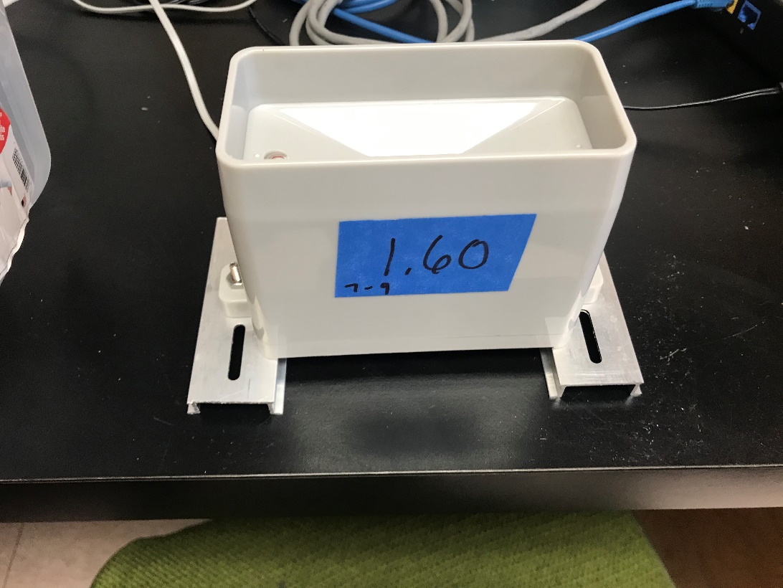

*Tipping bucket rain gauge (2’ x 4”) is placed under pizza pan drain hole to measure leachate volume. Rain gauge is connected to a pulse counter that displays the number of tips from which the total volume can be calculate (1.6 mL/tip).*

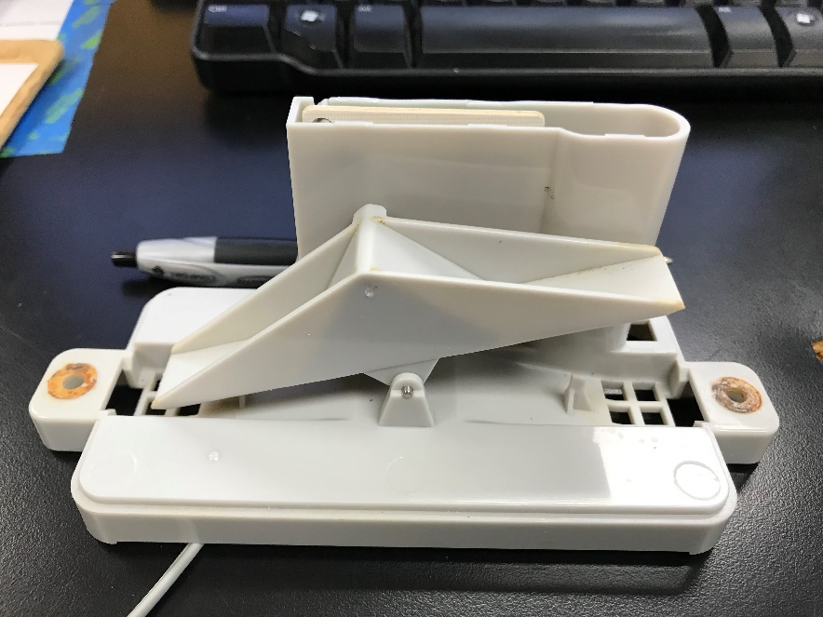

*Tipping bucket mechanism inside rain gauge. A magnet between the buckets activates a reed switch connected to a pulse counter.*

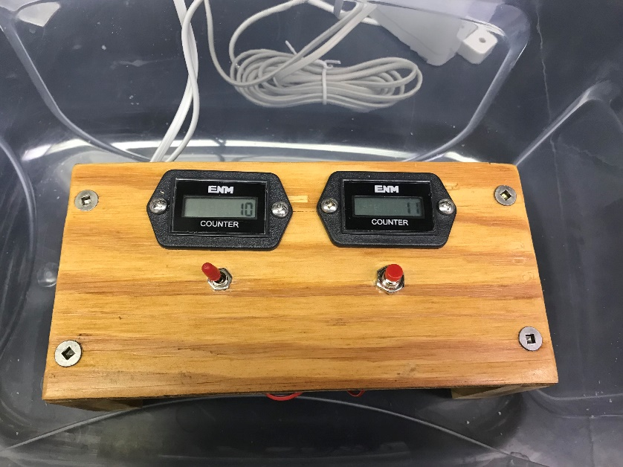

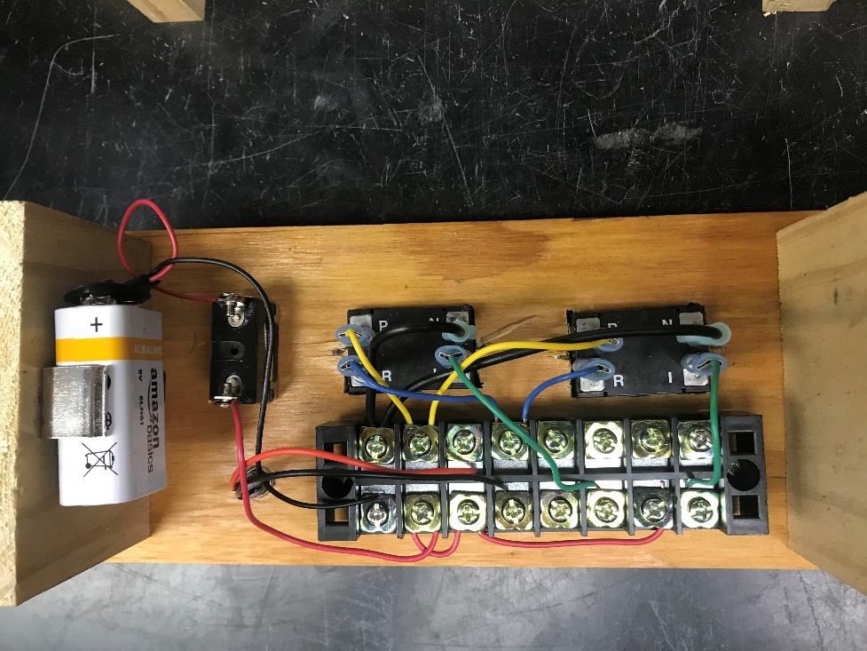

*A pair of pulse counters that record the number of tips from two rain gauges. The circuit is powered by a 9VDC battery and has on/off toggle switch and a push-button reset switch that zeroes the counters.*

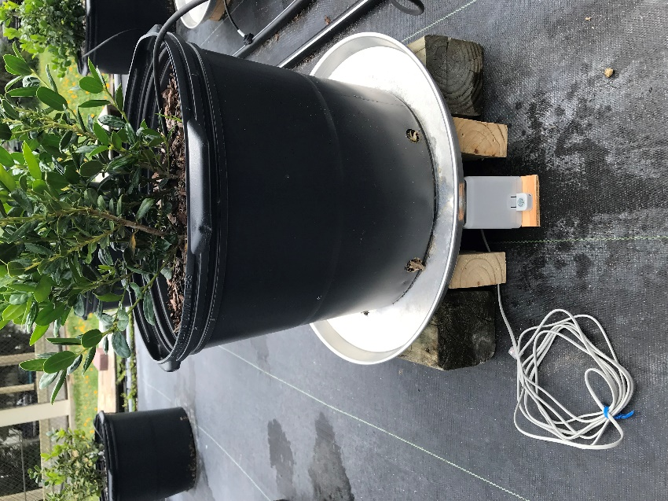

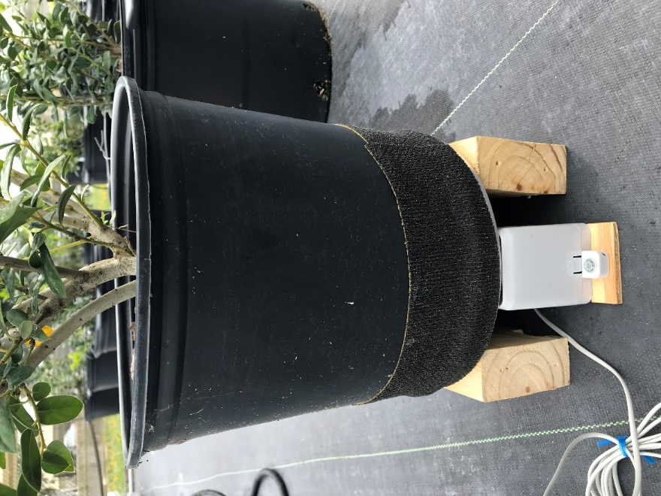

*The rain gauge is placed under an elevated pizza pan with a drain hole to direct leachate into the rain gauge. For sprinkler irrigation (lower photo), a sports wrap is used to keep irrigation water from entering the rain gauge.*

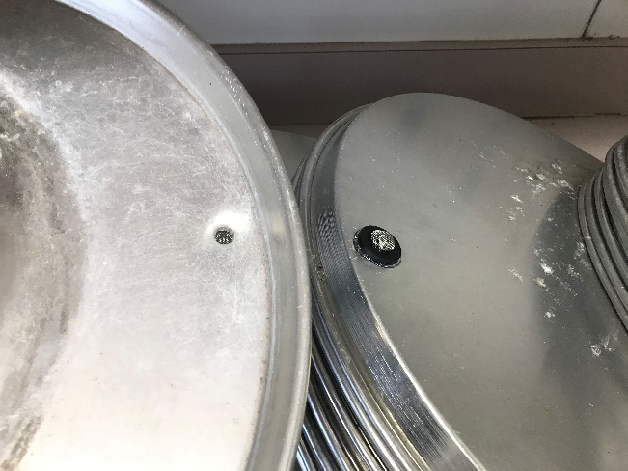 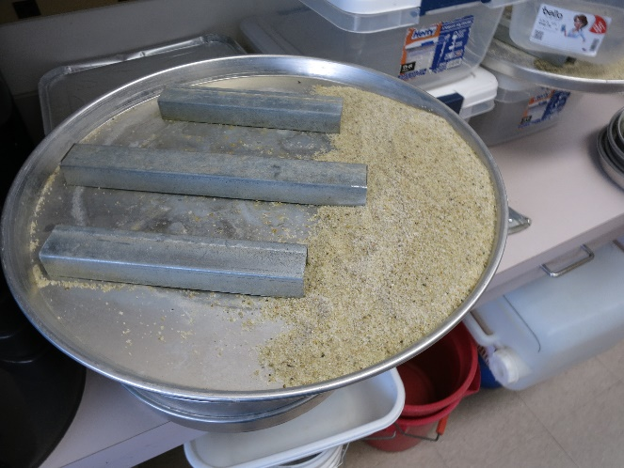

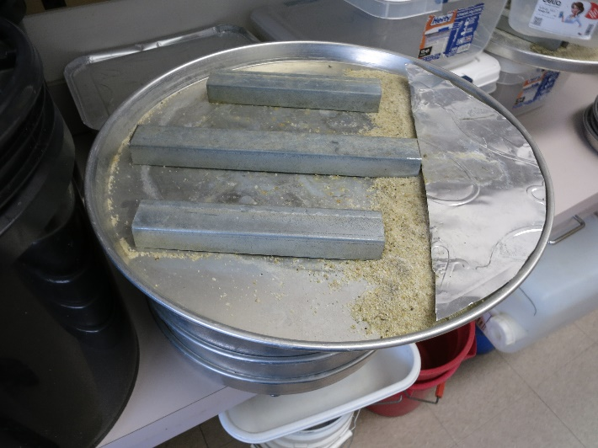 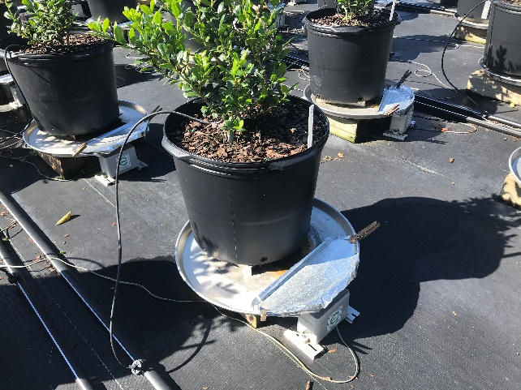

*For micro-irrigation, a sand filter slows the stream of leachate into the rain gauge. It also filters out debris than can clop rain gauge. If sand is exposed when using large pizza pans, a aluminum sheet limit evaporation of water retained by the sand filter. Container is elevated on pizza pan to prevent reabsorption of leachate.*

Parts for rain gauge system above ($50)

1. Rain gauge (WH‐SP‐RG spare part for weather station; MISOL International Ecommerce; <http://www.misolie.net/>)

2. Electronic counters with LCD display and 6 digits (2PAT7; Grainger; [www.grainger.com](http://www.grainger.com))

3. Miscellaneous wires, connectors and switches

*Note: Instead of electronic pulse counters, rain gauges can be connected as inputs to a PLC offering researchers an automatic method of monitoring leachate.*